CHD Prevention
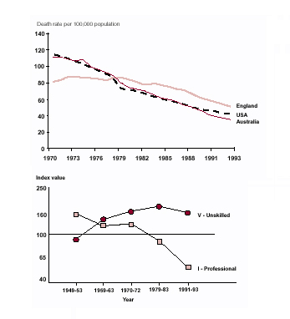
Coronary Heart Disease/Ischaemic Heart Disease

- 110000 deaths in England 1998
  - (41 000 <75’s)
- 4% decrease/year, but
  - not as fast as US, Australia
  - unequal
    - near 50% ARR in social class I
    - near 0% in social class IV-V

Risk Assessment

All based on the
FRAMLINGHAM data
10 year followup of 5000 residents of this Massachussetts town in the 1960’s

UNDERESTIMATES risk in…
known arteriopaths
familial hyperlipiaemia
FH of IHD
Non-Caucasians
1st degree relative
M<55 F<65
Primary Prevention only
Risk Factors
Joint British Societies Tables
Sheffield Tables
New Zealand Tables
10 year risk of IHD

Joint Societies Recommendations1998

Lifestyle targets for everybody
British Cardiac Soc,
British Hypertension Soc,
British Hyperlipidaemia Assoc,
British Diabetic Assoc.
Risk factor targets if 10 year risk of IHD > 15% and secondary prevention
Cardio-protective medication mostly in secondary prevention
DIET
Reduce fat
>5 portions fruit/veg per day
Reduce salt intake
>2 portions of fish (1 oily) per week
- DART study: 29% reduction in all mortality
“Mediterranean diet”
Moderate alcohol
- F 2u, M4u per week

SMOKING
Doubles risk of morbidity and mortality
Immediate benefit in cessation
Advice does increase quit rate
Nicotine replacement
Bupropion (Zyban)

Changes in

Life-style
Reduce RR by 50% in some studies

BMI
<25 kg/m2

EXERCISE
Inactivity= <3 sessions of 20mins vigorous activity
In these with symptomatic disease…
- 2/3 are overweight
- ½ take little or no exercise
- ½ eat too much fat
- 1/5 still smoke

Risk Factors
RR>15%
or secondary prevention
BMI <25
BP <140/85
Cholesterol <5
If RR >30 due to cost implications of statins
Diabetics:
BP < 130/80
HbA1c < 7

Cardio-protective Therapy
Secondary Prevention
Aspirin
Also in primary prevention if RR>15%
Beta-blockers
For >3 years
Statins
Also in primary prevention if RR>15% (minimum standard 30%)
ACE-I
If clinical LVF or LV dysfunction on echo but HOPE study since showed benefit of Ramipril regardless of LV function
Warfarin
If high risk of emboli

Comparison of NNTs.
(for 5 years to prevent 1 death)

Med diet 9
Oily fish 19
Stop smoking 21
Statins 26
β-blockers 30
Aspirin 37

The National Service Framework 2000
Based on Joint Society Recommendations

Targets…
- “to transform the prevention, diagnosis and treatment of Coronary Heart Disease.”
- Reduce IHD and CVA by 40% by 2010; 80-90% correct secondary prevention by April; reduce social inequalities in care and risk factors
- 12 standards of care

Population
  - #1. encourage changes in lifestyle
  - #2. reduce prevalence of smoking
Targeted; Primary care
  - #3. identify all those with established disease
  - #4. identify those at high risk of developing disease
- Audit; team meetings (yearly), agreed practice guidelines, disease registers, special clinics etc.

